**KickStarter Review**

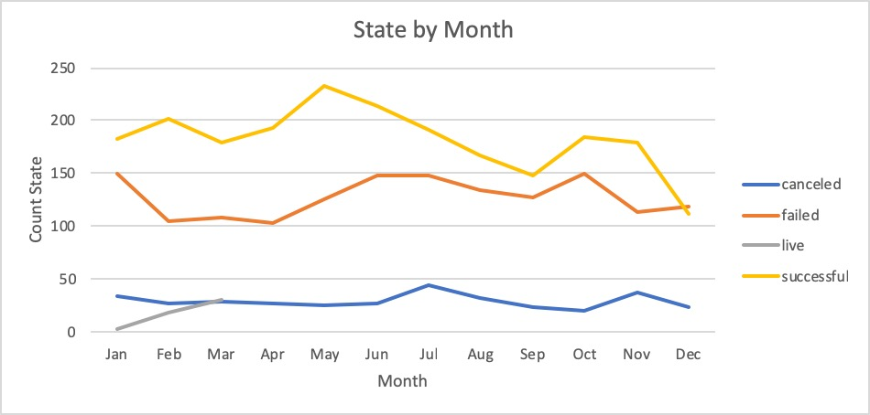

**Observations**

Q:

1.) What are three conclusions we can make about Kickstarter campaigns given the provided data?

2.) What are some of the limitations of this dataset?

3.) What are some other possible tables/graphs that we could create?

A:

1.)･Overall, there are higher successful Kickstarter campaigns than failed ones with the exception in December

･The amount of canceled campaigns stays steady below 50 in year round

･There is barely any project just stay living

2.)･The limitation would be not knowing what consider as canceled and live. Should they be categorize as failed when they were not success?

･The chart is difficult to see how are the success rate by month when the amount of campaigns is different by month. It would be better if with % rate instead of count.

･what are the cause of the fail and cancel, What makes a event to make it to spotlight, age group that funded the project

3.)

･We can create stacked bar graph with that would tell how much proportion of each state to total submitted campaigns by month or by category. We can also create scatter plot to see if there any correlation on % Funding received to success rate by category. Pie graph can be used as well to identify success and failed rate by country of origin of where the project from.